**Practicum Summary Report**

Company Name: PayActiv ltd

By

Masters Students at Leavey School of Business

Santa Clara University

[Fanyu Kong](mailto:fkong2@scu.edu)

[Hongjin Wu](mailto:hwu5@scu.edu)

[Kwun Wah Michael Chiu](mailto:kchiu@scu.edu)

[Krishna Sai Tejaswini Kambhampati](mailto:kkambhampati@scu.edu)

Submitted in fulfillment of the

MS 2022 : Industry Oriented Practicum

Under the Guidance of

Prof. Sunghun Chung

(Assistant Professor of Information Systems & Analytics at Santa Clara University)

Special Thanks to

Mr. Sohail Aslam (CTO of Payactiv)

Mr. Mitchell Oshima (Product Manager at Payactiv)

Mr.Karthik Mokashi (Data Scientist at Payactiv)

**CONTENTS:**

1. Project scope and objectives
2. Work plan and timeline
3. Findings
4. Benefits to PayActiv
5. Future Scope

**PROJECT SCOPE & OBJECTIVE**

**ABOUT PAYACTIV:**

Payactiv, Inc, is a certified B Corp and the leader in Earned Wage Access (EWA). Its award-winning Payactiv Lively app is the first digital wallet and financial-wellness platform designed to meet the specific needs of more than 80 million lower-income American workers. It is an all-in-one digital wallet offering EWA, unique discounts, integrated bill management and bill pay, goal-based savings, instant P2P funds transfer, and Payactiv Connect, a dynamic tool for communication.

**OBJECTIVE:**

The main objective of Project Reveal (our Practicum) is to understand ‘how’ users navigate the app, services usage, patterns and Timings etc. to unlock insights on user behavior to help increase stickiness and conversion rate to certain target events.

**DATALAKE DESCRIPTION:**

All the data generated from BI sources, Pageview and Click stream sources are collected and stored in a single table in Snowflake Datalake in Real-time. There are multiple versions of the app targeting different types of users which sometimes includes test records. Users have been broadly classified into Direct and Enterprise, however, most of the Enterprise users might initially enroll as a direct user and then link their respective employers and convert to Enterprise. Event timestamps per session per user are captured into the ‘CREATEDAT’ column showing microsecond level information, depending on user activity and causing thousands of records generated per session. A user can have multiple sessions per day and can view or click on several screens per session.Each view or click is also associated with multiple action names depending on the screen at use.

**CURRENT SCOPE:**

The scope of this project has been minimized to Direct user behavior as Payactiv is interested in features and services that attract Direct users; who cannot avail Payactiv’s main attractive feature - EWA ; to target product enhancements . Our final targets has been identified as:

* Proportion of Direct users enrolled over the last 2 years and applied for a payactiv card.
* Analyze the screen flow associated with user enrollment; Amount of time spent on each screen before a click or transaction takes place.
* Identify the Dropout screens of direct users and screen flow associated with it
* Among the features and discounts offered by Payactiv to direct users, identify the most popular features and the usage percentage among direct users
* Impact of PayActiv services, financial learning content on User saving ( # of saving attempts) or expenditure.

**WORK PLAN & TIMELINE**

**FINDINGS**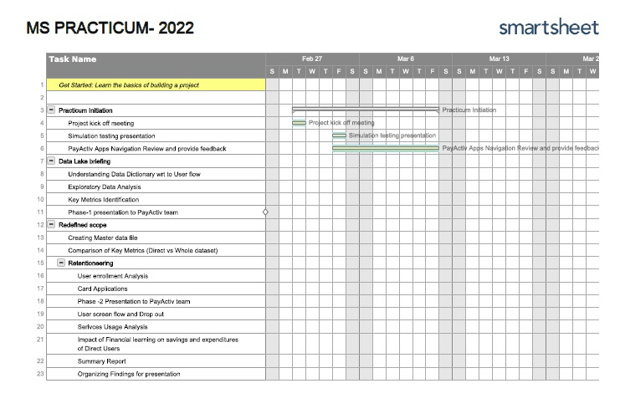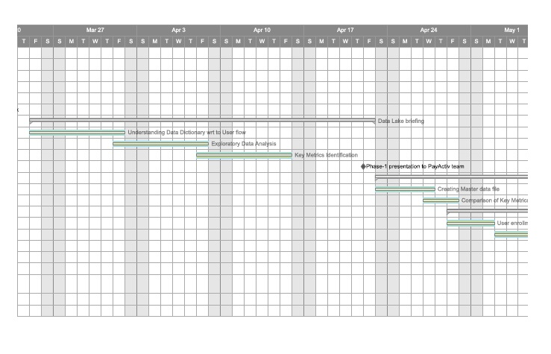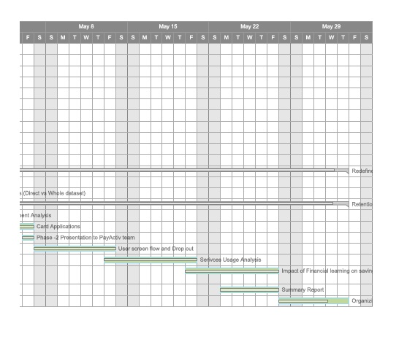

**Exploratory Data Analysis –**  Approach : Aggregate General User Flow over 2 years

Key Findings:

* Time spent on the app each login session on average by Direct Users is very less when compared to Enterprise Users, which is 5 mins and more than 30 mins respectively. However, the number of screen visited during one session for Enterprise Users is slightly less than for Direct Users, which may indicate that while Enterprise Users are using the services provided, Direct Users just browsing around
* Time interval between each login session of Direct Users is much longer when compared to Enterprise Users, which is normally less than 35 days and less than 9 days respectively
* Linking Employer and Linking SSN screens are identified as enrollment drop- out screens with a higher rate after first use or after a month
* Pay Friend is one of the stand-out card usage features for Direct Users, with on average $57 each time.
* Car Insurance seems to be the most visited non-card related feature over the last 3 months among Direct Users followed by Financial learning and Financial counseling
* Segmenting Users into session based clusters revealed that around 66% of Direct Users logged into the app only once. In Addition,the highest number of one session Logins has been observed during May-2021
* One-Session users tend to access the app more on Mondays and Sunday nights (compared with the entire dataset), which indicates that new users potentially have a higher conversion rate on Sunday nights and Mondays

**Retentioneering –** Approach : Used Retentioneering, a python library to explore feature based analysis of user trajectories. Performing funnel analysis on clustered groups, finding Screen adjacencies and step matrix to identify target event completions.

Key Findings:

1. Graph based visualizations to show the user path from point A to point B with focus on enrollment, card application, card utilization
   1. 51% of the Users who landed on the welcome screen tend to complete account creation.
   2. Among users who filled the application for card, more than 13% experienced the request Declined, despite linking SSN and filling personal information
2. Funnel Analysis Visualization to present engagement duration among different clusters
3. Impact : 17% of Users who visited financial learning articles created a Savings goal

**General User Flow Visualization and Behavioral Segmentation using Clusterization –**

Approach : Session based segmented users are further classified into groups through clusterization for further examination. Using ‘tf idf’ method screens corresponding to events are vectorized to indicate the weighted importance of the event occurrences. Given the size of data and limitation of computing resources, Ngram is set to (1,2), meaning unigram and bigram of events. The clusterization is conducted within each of the four groups. Within each cluster, we will focus on a higher percentage of conversion rate of auto insurance subscription rate, bill payment management service, saving, and direct deposit setup events against the cluster size and examine the cluster behavior.

Key Findings:

Below table summarizes the observations from the result of user flow visualization and clusterization.

| **Group** | **Observations (based on user flow visualization)** | **Cluster chosen** | **Cluster feature highlights** |
| --- | --- | --- | --- |
| 1 | 1) Low conversion rate of Direct Deposit, 8.6% of group 1 after sign up would proceed to Payactiv Direct, 46% of which converse to direct deposit  2) Low conversion rate of the remaining targets  3) connection from bill pay to auto insurance is observed (Probably bill payment service is linked to insurance premium)  4) Strong weighted connection between Payactiv Direct and Connect (Heavy dependance on customer live agent) | 4 | savings, connect,bill pay |
| 2 | 1) Low conversion rate of Direct Deposit, 9.7% of group 2 after sign up proceed to Payactiv Direct, 46% of which converse to applying the card  2) Low conversion rate of all the targets  3) connection from bill pay to auto insurance is observed  4) Strong weighted connection between Payactiv Direct and Connect (Heavy dependance on customer live agent) | 5,6 | cluster 5: card(very high % although slightly lower than the remaining cluster), savings, connect, billpay, direct deposit  cluster 6: card, url(plaid, money transaction activity) |
| 3 | 1) Low conversion rate of Direct Deposit, 9.8% of group 3 after sign up proceed to Payactiv Direct, 95% of which converse to applying the card  2) Low conversion rate of all the targets  3) connection from bill pay to auto insurance is observed  4) Strong weighted connection between Payactiv Direct and Connect (Heavy dependance on customer live agent) | 7 | payactiv, card(very high % although slightly lower than the remaining cluster), savings, billpay, rx discount, connect, direct deposit |
| 4 | 1) Low conversion rate of Direct Deposit, 9.9% of group 4 after sign up proceed to Payactiv Direct, 99% of which converse to applying the card  2) Highest conversion rate of all targets among the 4 groups (37% of people signing up will adopt Bill Payment Service, 19% of people signing up will enable direct deposit  3) However, low conversion rate is still observed for auto insurance | 6 | payactiv, card(very high % although slightly lower than the remaining cluster), savings, billpay, access plus, connect |

**A/B Testing and Experimentation –** Approach: Using January 2022 as a timeline to split the data into test and control groups.

* Test: One sided T test with 95% testing level
* Testing variable: To test the conversion rate of the four target events

Results:

* Direct Deposit conversion is more significant in 2022, indicating the demand of payroll advance access than the group in 2021
* Direct Deposit usually comes in effective later than the other target events, reflecting the difficulty to get the service effective
* For those who have control group being more significant than the test group, it means the features is not being used continuously in 2022, leak of users is a sign

**Machine Learning Pipeline**

* Feature Engineering: Label user status as inactive after idling for two months
* Goal: To predict user drop off (target var = status)
* Vectorizer: TFIDF
* Classifiers: Logistics Regression, Random Forest Classifiers
* Accuracy: 0.9, 0.94

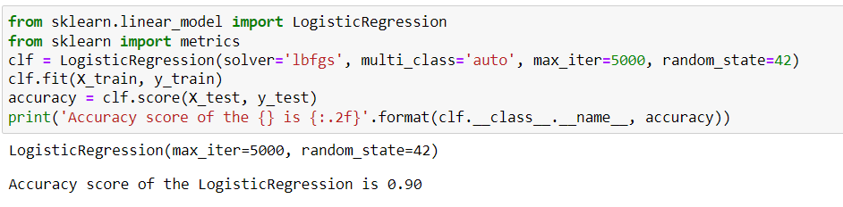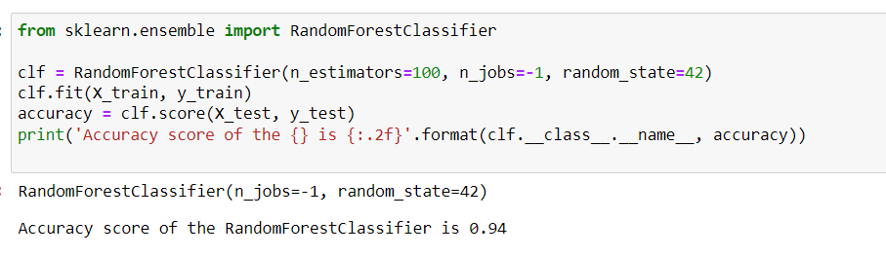

**Recommandation and insight**

* Live Agent:   
  Strong edge linkage between Connect and PayActiv Direct registration service indicates moderate to heavy dependance on customer live agent service, suggest conduct chatbot root cause analysis
* Launch Car Financing Product:  
  Given that prior to using PayActiv app, most of the users already possess a vehicle and no significant demand for purchasing new vehicle. Launch insurance bridging program, but need to know the current user insurance subscription expiry date, ads is needed to pop out to prompt users.
* Apps Enhancement  
  By default put the in-app product subscription service into the in-app bill payment service, or provide some pop-out to encourage users to converge to bill payment service after subscripting to in-app product service
* Improve PayActiv Direct Onboarding  
  Among all groups, low conversion rate to PayActiv Direct (to enrol with employers not in PayActiv Networks) after user successfully sign up/create account in PayActiv apps. A strong edge weight between PayActiv Direct and Card is observed, represented by the more-than-90-percent conversion rate, meaning users will incline to linking their card/bank account to the apps once they successfully enroll in the payroll advance program, suggesting getting user to successfully on-board PayActiv Direct service is the key to getting user bank/card linked to PayActiv apps. However, low conversion rate to direct deposit setup (deemed as auto credit transaction from the employer) after sign-up is low, after studying the process, a direct credit authorization form is needed to be executed between user and user’s employer. If the employer is not in PayActiv network and not familiar with PayActiv, employer might want to avoid the burden of administrative work. PayActiv should look into the Plaid search and study the companies (by names, segment) to expand customer outreach team to promote the apps and actively help user/company to onboard PayActiv apps, get the companies engaged in the PayActiv network, the goal is to eliminate the distinguishing effort between direct and enterprise user.

**BENEFITS FOR PAYACTIV**

1. Exploratory Analysis Findings: Helps visualize changes in trends with respect to features across seasons
2. A/B Testing Findings: helps to predict customer value and optimize operations to focus on most profitable segments
3. Recommendations:
   1. Launching auto financing programs to boost up auto-insurance subscription rate
   2. Some pop-out to encourage users to converge to bill payment service after subscripting to in-app product service
4. Dropout Screen Analysis: Understanding the screens where users tend to drop without performing actions not only help to enhance customer journey maps, but also reveals the attribution of any initiative they launch towards the customer experience.

**FUTURE SCOPE**

1. When more User Data ( like Demographics, Locations, Transactions ) can be made available, environmental attributes that can influence an outcome can be identified and by using regression analysis, models can be built to test and predict outcomes that maximize the ROI on services provided and marketing spend
2. A more promising approach to deep learning for Customer Behavior Analytics is to use Recurrent Neural Networks (RNN) which uses the customer journey data instead of summarized user attributes to generate behavioral patterns